ARCHITECTURE
[Please use block diagrams to show the architecture of your code.]
Exoplanet Data

Detrending the Data
(Gaussian filter + Normalize)
BLS Algorithm fitted to data

Removing upper outliers (clipping)
Attributes like Ingress, Egress, Depth, SR, SDE, Period of the Transit Extracted

Incremental PCA
(Top 165 features selected)
Normalizing

Combined Data

Stratified 5-fold Cross Validation + Bootstrapping
Modelling

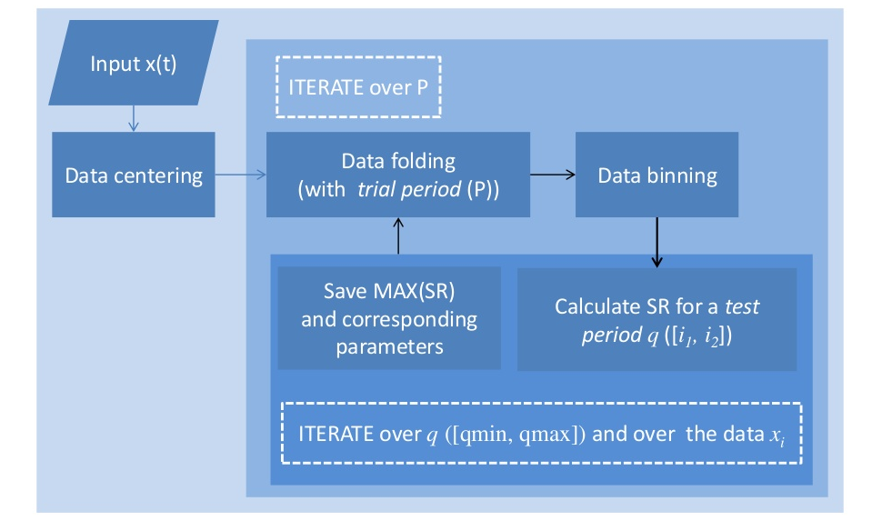
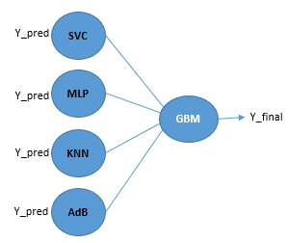

Modelling
BLS Algorithm

METHODOLOGY
[Mention how your algorithm works, cite references for techniques you’ve adopted from existing literature]
The algorithm used here is Box Least Squares(BLS) Algorithm. The BLS algorithm fits the input time series to periodic "box"-shaped functions. Periodic box-shaped functions represent the behaviour of a light curve during a transit better than sines and cosines; they are flat except for a repeated periodic dip in brightness that lasts, typically, for less than 10 percent of the total period. In the BLS algorithm, the signal is assumed to take on a "low" value for some fraction of the period and a "high" value for the remainder. To determine the fit of these periodic box-shaped functions to the signal, consider a set of candidate periods. For each period P, a time-series is "folded" to the period. For each data point i and time ti, and there is a corresponding phase given by the formula phasei = (ti modulo P) / P. All data points are then placed into phase bins. The algorithm then considers various ranges of bins based on the input minimum and maximum fraction of a period that may be spent in transit, and identifies the best bin range to designate as the "low" state.
Algorithm Parameters
- Number of bins - The BLS algorithm relies on binning data points and the number of bins may be specified as an input parameter. The goal is to choose the number of bins to achieve a balance between having a reasonable number of points in each bin and partitioning the phased time series into a reasonable number of pieces. "Reasonable" in each case depends on the number of points in your light curve.
- Fraction of period in transit - The BLS algorithm hypothesizes that some fraction of the period will be spent in the "low" state and the remainder in the "high" state.

The Features extracted from BLS algorithm are Ingress, Egress, Period, Depth of the Transit, Signal Residue, Signal Detection Efficiency. The flux data is detrended and the upper outliers are removed. Incremental PCA is applied to the data and the top 200 features are selected and combined with the features extracted from BLS algorithm. After Bootstrapping the train data, we apply an ensemble of models- Linear SVC, KNN, Neural Net and Adaboost as the base model and Gradient Boosting as the secondary model. We got Fscore of 0.86 in the test data splitted from the exoplanet dataset.

NOVELTY
[Please mention the novel aspects of your algorithm. This section has quite some weightage so make sure you think of something innovative in your algorithm.]
When the signal becomes distorted by higher harmonics, the sinusoidal representation fails. The BLS algorithm assumes only two levels of the periodic light curve- “high” and “low”. Here we divide the folded time series into 200 bins and evaluate the parameters using these binned values. In order to minimize the signal-to-noise ratio, we have removed the upper outliers using sigma clipping. For predicting the periodicity of the dips converting the time domain to frequency domain was necessary and hence FFT was used. After applying Fast-Fourier Transform we realized that the frequency plot was symmetric. So we took only half of the features. Also we have used Incremental PCA in our method since there were too many features. IPCA builds a low-rank approximation for the input data using an amount of memory which is independent of the number of input data samples. These dimensionality reduction methods helped in lowering the computational time significantly. Since the number of positive datapoints were too less, we have used bootstrap method to generate more positive datapoints. For classification purpose we have used an ensemble of learners since ensemble generally works better than individual models.

REFERENCES
[As mentioned before, make sure your citations are proper. Plagiarism can lead to disqualification]
Kovács, G., Zucker, S. and Mazeh, T., 2002. A box-fitting algorithm in the search for periodic transits. Astronomy & Astrophysics, 391(1), pp.369-377.
McCauliff, S.D., Jenkins, J.M., Catanzarite, J., Burke, C.J., Coughlin, J.L., Twicken, J.D., Tenenbaum, P., Seader, S., Li, J. and Cote, M., 2015. Automatic classification of Kepler planetary transit candidates. The Astrophysical Journal, 806(1), p.6.
https://www.kaggle.com/muonneutrino/exoplanet-data-visualization-and-exploration
http://www.stat.tamu.edu/~jlong/astrostat/fall2015/astr689.pdf
https://www.kaggle.com/aleksod/0-75-precision-0-60-recall-linear-svc
https://github.com/oscaribv/exotrending
http://www.konkoly.hu/staff/kovacs/bls.f
Jin, X. and Glass, D., 2014. Searching for exoplanets in the Kepler public data.

